ELECTRONIC ASSIGNMENT COVERSHEET | 

Student Number | 35497001
Surname | Phuphansakun
Given name | Wanchana
Email | Wanchanaphuphansakun@gmail.com
Unit Code | ICT206
Unit name | ICT206 Intelligent Systems
Enrolment mode | Face-to-Face
Date | 30 October 2025
Assignment number | 2
Assignment name | Project
Tutor | Sayma Shammi

Student’s Declaration:

- Except where indicated, the work I am submitting in this assignment is my own work and has not been submitted for assessment in another unit.
- This submission complies with Murdoch University's academic integrity commitments. I am aware that information about plagiarism and associated penalties can be found at http://www.murdoch.edu.au/teach/plagiarism/. If I have any doubts or queries about this, I am further aware that I can contact my Unit Coordinator prior to submitting the assignment.
- I acknowledge that the assessor of this assignment may, for the purpose of assessing this assignment:
  - reproduce this assignment and provide a copy to another academic staff member; and/or
  - submit a copy of this assignment to a plagiarism-checking service. This web-based service may retain a copy of this work for the sole purpose of subsequent plagiarism checking, but has a legal agreement with the University that it will not share or reproduce it in any form.
- I have retained a copy of this assignment.

I am aware that I am making this declaration by submitting this document electronically and by using my Murdoch ID and password it is deemed equivalent to executing this declaration with my written signature.

Signed Wanchana Phuphansakun

(Write your name in the space above)

Title

Introduction
Because this is a relatively small project,, these should be quite specific (respiratory diseases in cats, or fault-finding in 1990s Fiat cars). You should describe this clearly, perhaps using a scenario or examples question-and-answers , and what outputs the system must produce. Make sure you state at least one specific goal for your system, as clearly as possible. That is, it must be possible to see if the system has failed to meet the goal.

Background

Describe what prior experiments have been done on such a problem. Find some relevant papers using Google Scholar, or your library. Put the results of your reading to work. Use IEEE citations (numbers in square brackets) for all whose work you describe - corresponding to the list of references at the end. Briefly critique these works how well the worked and say what we learn from each.

AI Method and Tools

Give details of the process you actually used to create your system. Describe the tool you used. When necessary, give citations for the sources or research papers for these. Credit any other authors who were involved, and make sure to be clear about what is your work. Provide any results or listings that will not fit into the six-page limit in the Appendix.

Evaluation Method

Explain how you evaluated your system. Explain in detail the measurements or observations you used. Outline any practical difficulties you encountered; if you are not actually able to carry out your evaluation (for example, because you had no ethics permit to collect data from human participants), say how it should have been done, in detail.

Results

Give the results obtained from your experiments. If a classification task, for example, show how many of a test set were correctly classified, while if it was an optimisation method, show your optimal measure and compare with a theoretical ideal optimum. If a learning method, you should also include some indication of how quickly, and how well your system learned. Typically, this takes the form of a graph with some measure of learning quality on the y-axis and time or learning epochs on the x-axis. Make sure you clearly label all graphs and tables, and provide a caption for each. For some applications like games, it may be easier to show the results in the form of pictures (do screen captures - eg using PrntScrn - and insert them as with captions “Figure 1. User interface for the expert system”, etc. so that you can refer to them in the text)

Fig. 1. A sample line graph using colours which contrast well
both on screen and on a black-and-white hardcopy
Conclusion

Interpret the results for the reader. How can we understand what has happened? Was the goal reached, and to what degree? Was the outcome what you expected? What have you learned by doing the experiment? What went well, and what went poorly? What could be done to improve the performance of the method in future? What is your conclusion?

Acknowledgements (if needed)

If you are given help or use code taken from some source, acknowledge these here. If you modify code obtained from the Internet, remember to observe the copyrights of the code obtained, and make proper reference to the author.

References

It is important to provide appropriate references for the materials you have used. Use the IEEE style and try to avoid anonymous, random websites if possible. If you are not sure how to cite references, see http://libguides.murdoch.edu.au/IEEE

Appendix (if needed)

One or more of these giving extra data, results, code listings etc. which is too long to go inside the report. (Does not count toward your six page limit.)

User Guide

Brief but detailed instructions on how to run and/or use the program. It should be clear enough for you to re-generate your results to verify your report. Do not expect your tutor to install very large or complex programs to run your code – there will not be time. If it will need that, arrange to demonstrate the working code on your own machine during the Week 12 or 13 labs. (Usually just a few lines. You can put all this the appendix – it does not count toward your six page limit.)

Make sure your work is properly checked for grammar and spelling before submitting. Submit one file (this filled-in Word template) by the due date via the ICT206 unit website. Students are warned about taking material from the Web or generated by an LLM without proper acknowledgment, which is considered misconduct.

Appendicitis Prediction Artificial Neural Network

Link to Google Colab notebook: https://colab.research.google.com/drive/14yGv1tpKW7NrMzw9O2eV8ebHSyP_jwDa?usp=sharing

Introduction
Acute abdominal pain is common in children and adults. However, diagnosing the causes of it is extremely difficult and time-consuming. Providing a precise diagnosis is one of the most challenging tasks for doctors [1]. The overall rate of mortality for appendicitis was 0.28 percent. Additionally, the mortality rate is higher in undeveloped countries, ranging from one to four percent, due to delayed diagnosis and treatment. If appendicitis patients get diagnosed early and get decent treatment, they could recover within one to two days without additional surgery, depending on the type of appendicitis [2]. This evidence suggests that early diagnosis is critically important. Therefore, machine learning (ML) could be a valuable option to assist clinicians. It could identify non-obvious patterns of data that humans would not be able to observe.
This project will focus on developing an Appendicitis Prediction System using an Artificial Neural Network (ANN). The system will take patients' data as input, such as age, BMI, and weight, and provide a prediction based on this data. The goal of the system is to achieve high accuracy for real-world use. For clinical prediction models, an accuracy between 0.8 and 0.9 means the model performs excellently [3]. Thus, the goal of the system is to achieve high accuracy (more than 85 percent) for real-world use.

Background
There are numerous studies on Machine learning for appendicitis prediction. However, this report will focus on two studies: “Machine-learning based prediction of appendicitis” and “Predicting severity of acute appendicitis with machine learning methods.” These are among the highest-accuracy models, utilizing innovative techniques.
“Machine-learning based prediction of appendicitis” by Schipper is one of the most interesting journals because its ML model achieved an AUROC of 0.919 without laboratory test results. Still, the model was trained on only 336 eligible cases of the dataset [4]. This study was conducted on a small dataset, yet it still achieved excellent results. This shows that we don’t need a massive dataset to achieve outstanding results.
“Predicting severity of acute appendicitis with machine learning methods” focused on six different ML algorithms with 1568 patients’ records. Six algorithms in the study: “k-Nearest Neighbor (k-NN), Decision Tree (DT), Logistic Regression (LR), Support Vector Machine (SVM), Gaussian Naïve Bayes (GNB), and Multi-Layer Perceptron (MLP)” [5]. The results of the study showed that MLP achieves the highest AUC at 92 percent. This suggests that to achieve a higher AUC, the ML algorithm is crucial for success. Moreover, when comparing the dataset to another study's dataset, we notice that a larger dataset tends to achieve a higher AUC.
AI Method and Tools
This report will utilize a supervised Artificial Neural Network (ANN) to diagnose appendicitis based on clinical data. A Supervised Artificial Neural Network (ANN) is a machine learning model that uses a labeled dataset to train a model. It is commonly used to solve a variety of problems because it contains only three main components: input layer, hidden layer(s), output layer [6]. The input layer is the layer where a model receives data. The hidden layer(s) will perform a nonlinear transformation and detect patterns. Lastly, the output layer will produce the prediction.
The system was developed in Google Colab. Google Colab is a cloud-based Python environment that includes all the necessary libraries to build a model. Pandas is used for data preparation before passing it to a model. NumPy is used for array operations and data conversion. Scikit-learn is used for data splitting and computing evaluation metrics. TensorFlow and Keras are deep-learning frameworks that will be the central part of the ANN model. Matplotlib provides data visualization tools, such as plotting graphs.

Data loading
The Regensburg Pediatric Appendicitis dataset from Kaggle is used for the model training [7]. The dataset comprises 782 rows of cases and 53 columns, including age, BMI, and other relevant variables. The CSV file (Regensburg Pediatric Appendicitis.csv) will be read into the system by a Pandas function (read_csv).

Data cleaning
After loading all data into the system, some data may be missing due to incomplete data collection. Therefore, it is crucial to clean and analyze data before feeding it to the model. For example, call the replace method from Pandas to replace infinite values with NaN. Additionally, the model does not understand human languages such as “no appendicitis” or “appendicitis”. In the dataset, the “Diagnosis” column is stored as a text field, which cannot be used directly to train the model. Thus, it needs to be converted to binary values (0 or 1). I used Pandas method (.apply) to convert each row to numeric values.

Building and training the ANN model
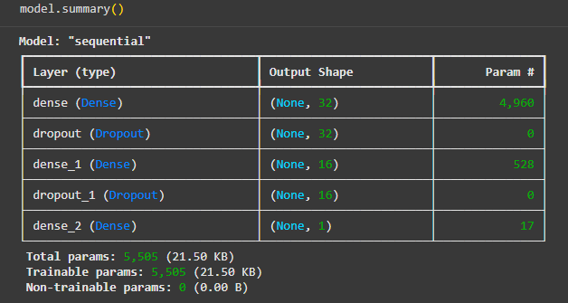
The Artificial Neural Network (ANN) model is built using TensorFlow and Keras in Google Colab. The model contains three main layers. Firstly, the input layer receives all features from the dataset. Secondly, two hidden layers: the first hidden layer with 32 neurons and ReLU activation, and the second hidden layer with 16 neurons and ReLU activation. Lastly, the output layer consists of one neuron with a sigmoid activation function, which is used to predict the presence of appendicitis. For the training part, 80 percent of the dataset will be dedicated to training the model with 200 epochs. Moreover, 20 percent of the training dataset will be split into validation datasets, which will be used during the training process.
Table 1. The model summary shows the model details.

Evaluation Method
For the testing part, the trained model will be evaluated using 20% of the dataset that was split during the data cleaning process. Therefore, we will use the x and y test sets to evaluate the trained model using these four metrics. Accuracy is a percentage of overall correct predictions. Secondly, AUC (AUROC) refers to the Area Under the ROC Curve, which measures how well the model performs in distinguishing between positive and negative cases. Thirdly, sensitivity (True Positive Rate) is a rate that tells how many appendicitis cases the model can correctly detect from all real appendicitis cases. Lastly, specificity (True Negative Rate) is a rate that indicates how many non-appendicitis cases a model can correctly detect from all negative cases.

Results
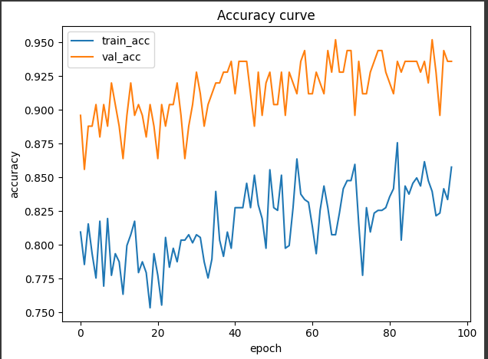
The model was trained using a training dataset with 200 epochs. However, after 200 epochs, the model could not achieve the goal (80 to 90 percent accuracy). To achieve the goal, I need to optimize the number of epochs to 300. After optimization, the model was trained again and achieved the goal at 97 epochs. Figure 2 shows that the model achieves 85% accuracy on the training set and 93% accuracy on the validation set.
Figure 2. The Accuracy result of the model on training set and validation set
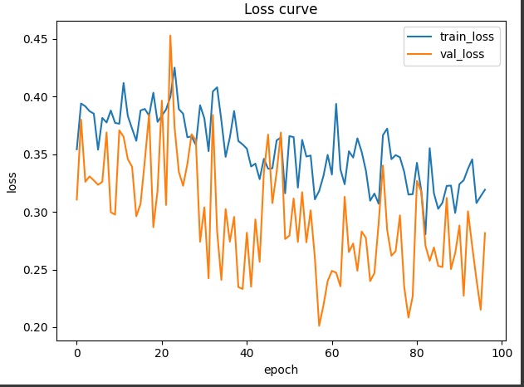
Moreover, the model also achieves a low loss value during training. Figure 3 shows that the model has a loss value of approximately 0.30 on the training set and 0.28 on the validation set.
Figure 3. The Loss Curve result of the model on training set and validation set
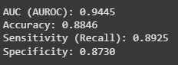
After training, the trained model was evaluated using four metrics on the test dataset: Accuracy, AUROC, Sensitivity, and Specificity.
Figure 4. Evaluation methods: Accuracy, AUROC, Sensitivity, and Specificity.

Figure 4 shows that the model achieved an AUC of 0.9445 on the testing set, indicating that it effectively separates appendicitis cases from non-appendicitis cases. Secondly, the model achieved an accuracy of 88.46% on the testing set, suggesting that it performed exceptionally well. Thirdly, the model achieved a sensitivity of 0.8925 on the testing set. This means the model could effectively predict the actual positive cases. Lastly, the model achieved a specificity of 0.8730 on the testing set. This means the model could effectively predict the actual negative cases.

Conclusion
The Appendicitis Prediction Artificial Neural Network model was developed using TensorFlow and Keras in Google Colab. The model was trained and tested on the split dataset. The accuracy curve indicates that the model learned smoothly during training. However, the model requires a high number of epochs to achieve its goal. The results suggest that the model successfully achieved its goal, with an accuracy of 88.46% and an AUC of 0.9445. Moreover, the sensitivity (0.8925) and specificity (0.8730) show that the model performed excellently. In short, these outcomes met the expectations that the model should perform well on the dataset.
In conclusion, the model requires optimization of the epoch during training, after addressing the identified issues and retraining the model three times. Ultimately, the model performed as expected and successfully achieved all its objectives.

Acknowledgements
The central part of the model (the model architecture) was made of open-source frameworks from TensorFlow and Keras. The frameworks provided architectures and tools for building and training Artificial Neural Network models.

References
[1] A. Bhangu, P. K. Soreide, S. D. Saverio, J. H. Assarsson, and F. T. Drake, “Acute appendicitis: modern understanding of pathogenesis, diagnosis, and management”, Emergency surgery, vol. 386, no. 100, pp. 1278-1278, September. 2015, doi: https://doi.org/10.1016/S0140-6736(15)00275-5
[2] S. Lotfollahzadeh, RA. Lopez, and JG. Deppen, “Appendicitis”, StatPearls, 12 February, 2024. [Online]. Available: https://www.ncbi.nlm.nih.gov/books/NBK493193/
[3] N. White, R. Parsons, G. Collins, and A. Barnett, “Evidence of questionable research practices in clinical prediction models”, BMC Medicine, vol. 21, no. 339, September. 2023, doi: https://doi.org/10.1186/s12916-023-03048-6
[4] A. Schipper, P. Belgers, R. O’Connor, et al., “Machine-learning based prediction of appendicitis for patients presenting with acute abdominal pain at the emergency department”, World J Emerg Surg, vol. 19, no. 40, December. 2024, doi: https://doi.org/10.1186/s13017-024-00570-7
[5] H. Yazici, O. Ugurlu, Y. Aygul, et al. “Predicting severity of acute appendicitis with machine learning methods: a simple and promising approach for clinicians”, BMC Emerg Med, vol. 24, no. 101, June. 2024, doi: https://doi.org/10.1186/s12873-024-01023-9
[6] S. Walczak and N. Cerpa, “Encyclopedia of Physical Science and Technology”, ScienceDirect, 2003, [Online]. Available: https://www.sciencedirect.com/referencework/9780122274107/encyclopedia-of-physical-science-and-technology#book-info
[7] S. Hedonist, October 2023, Kaggle, [Online]. Available: https://www.kaggle.com/datasets/zsinghrahulk/regensburg-pediatric-appendicitis

Appendix
Model creating
model = keras.Sequential([
keras.Input(shape=(X_train.shape[1],)), # This is the input layer
layers.Dense(32, activation="relu"), # This is first hidden layer with 32 neurons and "relu" activation
layers.Dropout(0.4), # This layer will dropout 40% of the neurons during training. To anti-overfitting
layers.Dense(16, activation="relu"), # This is second hidden layer with 16 neurons and "relu" activation
layers.Dropout(0.3), # This layer will dropout 30% of the neurons during training. To anti-overfitting
layers.Dense(1, activation="sigmoid"), # This is the output layer with 1 neuron output and "sigmoid" activation
])

model.compile(
optimizer=keras.optimizers.Adam(1e-3), # This will set optimizer to Adam optimizer with 0.001 learning rate.
loss="binary_crossentropy", # To measure how wrong the model is.
metrics=[
keras.metrics.AUC(name="auc"),
"accuracy"
]
)

model.summary()

Evaluation Code
from sklearn.metrics import confusion_matrix, roc_auc_score, accuracy_score, recall_score

# Probabilities and predictions
probs_test = model.predict(X_test, verbose=0).ravel()
preds_test = (probs_test >= 0.5).astype(int)

# Core metrics
test_auc = roc_auc_score(y_test, probs_test)
test_acc = accuracy_score(y_test, preds_test)

# Confusion matrix
cm = confusion_matrix(y_test, preds_test)
tn, fp, fn, tp = cm.ravel()

# Sensitivity and Specificity
sensitivity = tp / (tp + fn)
specificity = tn / (tn + fp)

print(f"Accuracy: {test_acc:.4f}")
print(f"AUC (AUROC): {test_auc:.4f}")
print(f"Sensitivity (Recall): {sensitivity:.4f}")
print(f"Specificity: {specificity:.4f}")
print("\nConfusion Matrix:")
print(cm)

Save Model and MetaData
model.save(MODEL_PATH)

meta = {
"target_col": TARGET_COL,
"feature_cols": feature_cols,
"label_strategy": "1 if Diagnosis contains 'append', else 0",
}
with open(META_PATH, "w") as f:
json.dump(meta, f, indent=2)

print("Saved model to:", MODEL_PATH)
print("Saved metadata to:", META_PATH)

User Guide
This user guide provides instructions on how to rerun the model to verify the results, as stated in this report.
- Download the zip file (ICT206 Appendictis Prediction Wanchana Phuphansakun.zip) and extract the file to a folder (the folder includes Regensburg Pediatric Appendicitis.csv)
- Open the link: https://colab.research.google.com/drive/14yGv1tpKW7NrMzw9O2eV8ebHSyP_jwDa?usp=sharing
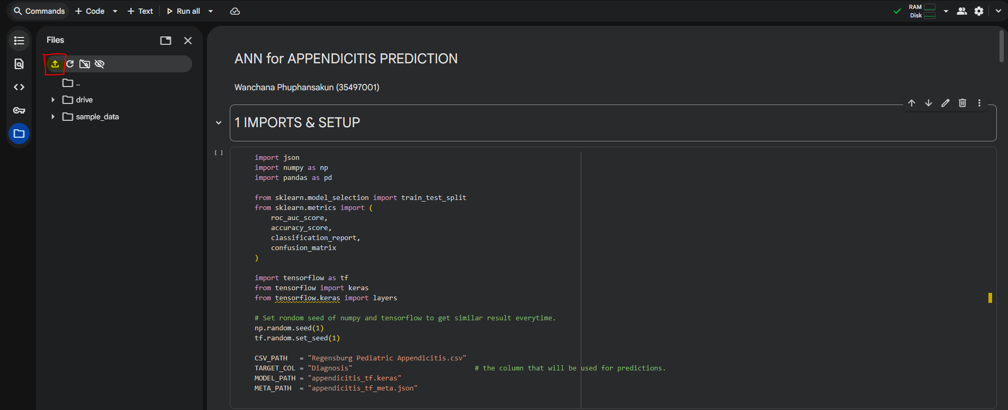
- Upload the file into Google Colab. Click on the left top of the page as shown in figure 5.
Figure 5. show the upload button
- Select and upload "appendicitis_tf.keras" "appendicitis_tf_meta.json" "Regensburg Pediatric Appendicitis.csv" from the extracted folder (ICT206 Appendictis Prediction Wanchana Phuphansakun).
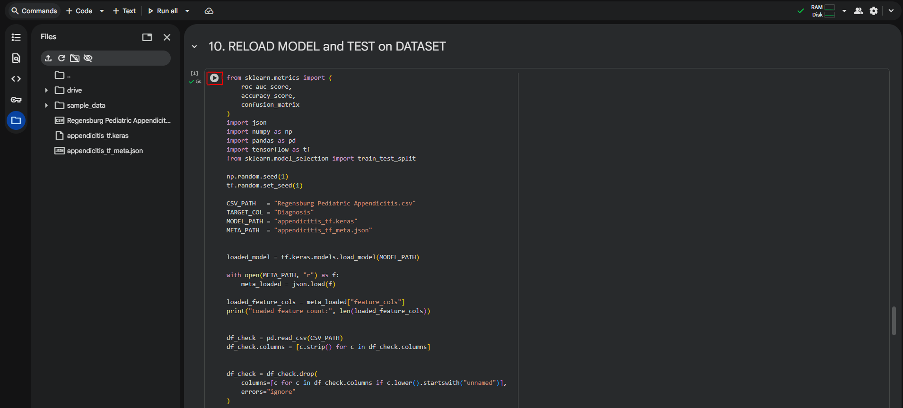
Figure 6. show the upload button
- Scroll down to topic 10 and click on the play button as shown in figure 6.
- The results should display at the bottom of the code block.

The submission will be marked using the following rubric:

CATEGORY | 5 | 4 | 3 | 2 | 1 | 0
On Time/Late  Without Extension | On time  0 marks | 1-2 days late  -1 marks | 3-4 days late  -2 marks | - days late  -3 marks | 7 or more days late  -4 marks
Presentation  (coversheet, diagrams, captions, references in IEEE format, clarity and style) | Excellent  +5 marks | Very good  +4 marks | Good  +3 marks | Acceptable  +2 marks | Poor  +1 mark | Very Poor  0 marks
Description  (problem, background research and goal) | Excellent  +5 marks | Very good  +4 marks | Good  +3 marks | Acceptable  +2 marks | Poor  +1 marks | Very Poor  0 marks
Solution & Implementation  (good solution, good use of tools and resources) | Excellent  +5 marks | Very Good  +4 marks | Good  +3 marks | Acceptable  +2 marks | Poor  +1 mark | Very Poor  0 marks
Performance of Solution  (solution runs according to design, goals reached) | Excellent  +5 marks | Very Good  +4 marks | Good  +3 marks | Acceptable  +2 marks | Poor  +1 mark | Very Poor  0 marks
Evaluation & Conclusion  (quality of evaluation, conclusion) | Excellent  +5 marks | Very Good  +4 marks | Good  +3 marks | Acceptable  +2 marks | Poor  +1 mark | Very poor  0 marks

Tutor’s Comments

